IBBERTON PLATINUM JUBILEE QUIZ
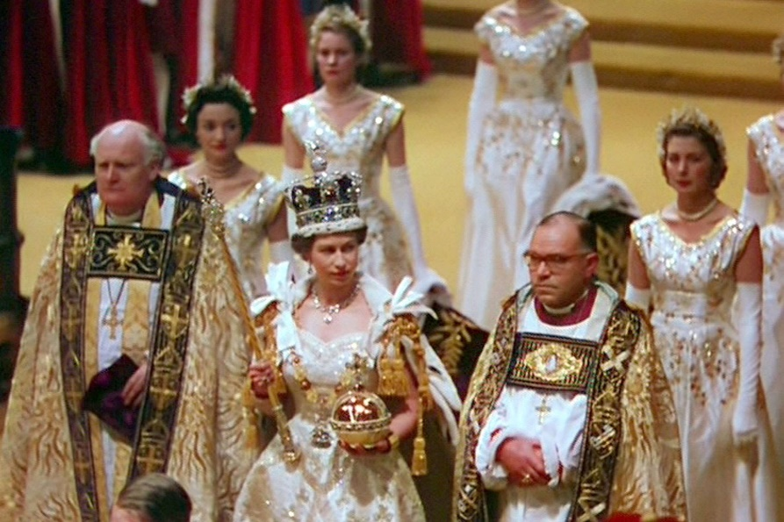
This Photo by Unknown Author is licensed under CC BY-NC-ND

TAKE A JOURNEY DOWN MEMORY LANE THROUGH THE 70 YEAR REIGN OF QUEEN ELIZABETH II.

THERE ARE NO PRIZES BUT HOPEFULLY YOU WILL HAVE SOME FUN AND IT WILL BRING BACK A FEW MEMORIES FOR YOU. “That was before my time” COMMENTS ARE FORBIDDEN!

THE QUESTIONS, AND ALSO THE ANSWERS IF YOU NEED THEM, ARE AVAILBLE ON THE HOME PAGE OF THE IBBERTON PARISH COUNCIL WEB SITE. JUST TYPE “IBBERTON PARISH COUNCIL” INTO YOUR SEARCH ENGINE

1952 – At which Kenyan resort was Princess Elizabeth staying when she heard she had succeeded to the throne?
1953 - Which jockey won the Derby this year at the age of 49, still the only jockey to have been knighted?
1954 – Marilyn Monroe married which American baseball star?
1955 – Which film highlighting the exploits of Guy Gibson and 617 squadron was released this year?
1956 – Who was British prime minister during the Suez Crisis of this year?
1957 – Which famous music club opened its doors in Liverpool?
1958 – Which award recognising achievements by young people was extended to include girls as well as boys in this year?
1959 – Which iconic car designed by Sir Alec Issigonis was first launched by the British Motor Company in the UK?
1960 – Having been banned since 1928, which novel by DH Lawrence was published this year, selling over 200,000 copies in a single day?
1961 – “Barbie” got a boyfriend – called??
1962 – The BBC satire show nicknamed “TW3” was launched with David Frost, Millicent Martin and others – what was its full name?
1963 – On 8th August which famous heist took place in Buckinghamshire?
1964 – Leslie Crowther took over as host of what popular BBC children’s programme?
1965 – Which decoration did the Queen present to the Beatles?
1966 – The Queen presented the Jules Rimet Trophy to which English football captain?
1967 – Who died on Coniston Water attempting to break his own water speed record?
1968 – Which English music festival (not Glastonbury) was first held this year, headlined by Jefferson Airplane?
1969 – Which new London Underground line was opened by the Queen?
1970 – Which coin ceased to be legal tender?
1971 – Who was stripped of his British Show-jumping Championship for making a “v” sign?
1972 – Which popular poet, famous for the line “come friendly bombs and fall on Slough, it isn’t fit for humans now”, was made Poet Laureate by the Queen?
1973 – Who did Princess Anne marry?
1974 – Abba won the Eurovision Song Contest in which seaside English town (now a city)?
1975 – Which iconic single by Queen was released and topped the charts for 9 weeks?
1976 – Which IT company was started by Steve Jobs and Steve Wozniak and launched its first personal computer in April?
1977 – Who won the Ladies Singles at Wimbledon in the Silver Jubilee year?
1978 – Which Andrew-Lloyd Weber musical based on the life of Eva Peron opens in the West End?
1979 – The final episode of which TV sit-com set in a hotel in Torquay was broadcast in October?
1980 – Who became prime minister of Zimbabwe, retaining power until 2017?
1981 – Princess Alice, Countess of Athlone, dies at the age of 97. She was the last surviving grandchild of which monarch?
1982 – Which British Army Colonel was awarded a posthumous Victoria Cross after the Battle of Goose Green in the Falklands War?
1983 – Which Derby winning racehorse was kidnapped from his stud and eventually killed by the IRA?
1984 – Torville and Dean won figure skating Olympic gold in which European city?
1985 – Queen stole the show at Live Aid – their members were Roger Taylor, John Deacon, Brian May and who?
1986 – What finally completed Motorway was opened by Margaret Thatcher?
1987 – Which royal prince dropped out of the Royal Marines after 4 months basic training?
1988 – Which Health Minister created uproar when saying most eggs in production in the UK were contaminated by salmonella?
1989 – Betteshanger Colliery closes – the last coal mine in which south-eastern English county?
1990 – Which German discount supermarket opened its first UK branch?
1991 – Who became the first Briton in space?
1992 – With what two-word Latin phrase did Her Majesty describe this year?
1993 – Which American singer-songwriter released the song River of Dreams which includes the line “England’s got a new Queen”?
1994 – What 32 mile long, underground structure was officially opened?
1995 – From which long-running soap did Julie Goodyear leave after 25 years playing Bet Lynch?
1996 – Which royal couple were divorced this year?
1997 – What was the name of the first cloned sheep born in the UK this year?
1998 – Who hosted the new ITV game show, “Who Wants to be a Millionaire”?
1999 – Which royal couple married at St Georges Chapel, Windsor?
2000 – Which infamous doctor was found guilty of murdering 15 patients between 1995 and 1998?
2001 – Which film about a young wizard was released this year?
2002 – Whose funeral took place in Westminster Abbey – she was 101 years old?
2003 – Which supersonic aircraft made its last commercial flight?
2004 – Which journalist, now an opinionated TV presenter, was sacked as editor of the Daily Mirror?
2005 – Where in Hampshire became the 12th National Park in England?
2006 – Which north London football club’s new stadium was opened by the Duke of Edinburgh?
2007 – Who won a Golden Globe, a BAFTA and an Oscar for her starring role in “The Queen”?
2008 – Whose debut album “19” was released this year?
2009 – Which flamboyant celebrity TV chef, rarely seen without a glass of wine in his hand, died of a heart attack?
2010 – Which actress played Princess Elizabeth’s mother in the film “The Kings Speech”?
2011 – Which city in New Zealand was badly damaged by a powerful earthquake?
2012 – Who won the gold medal in the men’s tennis at the London Olympics?
2013 – Which royal Prince was born on 22nd July?
2014 – Which venue in Russia hosted the Winter Olympics?
2015 – Who was elected as Leader of the Labour Party?
2016 – Which football team won the Premier League, having been 5,000:1 outsiders at the start of the season?
2017 – Which east Yorkshire city became the UK City of Culture for the year?
2018 – Who were married on 19th May in St Georges Chapel, Windsor watched by a worldwide TV audience of an estimated 1.9 billion?
2019 – Tiger Roll wins which horse race at Aintree for the second time?
2020 – Who was elected (and still is) Leader of the Liberal Democrats?
2021 – Who won the US Open tennis women’s singles?
2022 - What is the name of the new Crossrail train line opened in London on 24th May?

